**HALF AND FULL WAVE RECTIFIER**

**HALF WAVE:**

uses **one diode**, allows only one half of the AC cycle.

**COMPONENTS NEEDED IN TINKERCAD:**

· 1 x AC Power Source (e.g. Function Generator or Sine Wave Generator)

· 1 x Transformer (optional for stepping voltage)

· x Breadboard

· 1 x Load Resistor (1kΩ)

· 1 x Capacitor (optional for smoothing)

· Wires

**Half-Wave:**

1 x Diode (e.g., 1N4007)

## HALF-WAVE RECTIFIER – TINKERCAD PROCESS

### STEP 1: Set up AC Source

Use **Function Generator**.

Set waveform: **Sine**

Frequency: 50 Hz

Peak Voltage: 10V

### STEP 2: Connect Diode

Connect the **anode** of the diode to the AC positive terminal.

**Cathode** (silver band side) to one end of the **resistor (load)**.

### STEP 3: Load and Ground

Connect the other end of the resistor to the **AC ground (negative terminal)**.

Use **Oscilloscope** or **Multimeter** across the resistor to observe DC output.

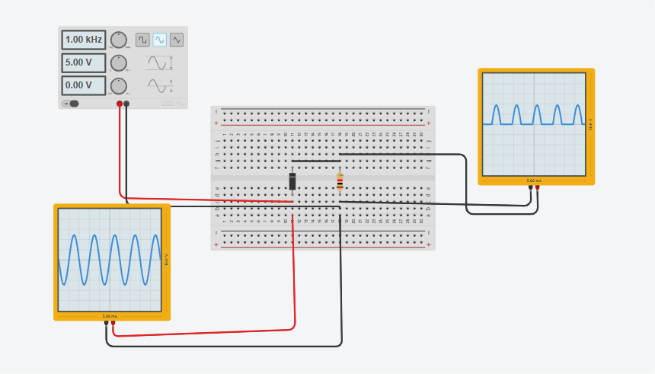

**FULL WAVE:**

uses **four diodes** (bridge rectifier), allows both halves.

## COMPONENTS NEEDED IN TINKERCAD:

1 x AC Power Source (e.g. Function Generator or Sine Wave Generator)

1 x Transformer (optional for stepping voltage)

1 x Breadboard

1 x Load Resistor (1kΩ)

1 x Capacitor (optional for smoothing)

Wires

**Full-Wave:**

4 x Diodes (1N4007) – arranged in a bridge configuration

## FULL-WAVE RECTIFIER – TINKERCAD PROCESS:

### STEP 1: Setup AC Source

Again, use **Function Generator** as AC source.

### STEP 2: Build Bridge Using 4 Diodes

Diodes D1 & D3: Anodes to AC input

Diodes D2 & D4: Cathodes to AC input

Connect:

**D1 cathode + D2 anode** → Positive output

**D3 cathode + D4 anode** → Negative output

### STEP 3: Connect Load

Connect resistor across positive and negative output.

### STEP 4: Optional – Add Capacitor

Add a **capacitor (100µF or more)** across the resistor for smoother DC output.

### Screenshot 2025-08-06 084147(1)